ES Lab Manual

Fontys ICT  
Version 1.0; July 2019  
Authors: Filip Georgiev, Jaap Geurts

Table of Contents

1. Introduction 1

2. Terminology 1

3. Delivery and grading 1

4. Equipment 1

5. Setup and Installation 2

6. Week 1 4

6.1. Getting started 4

6.2. Simply serial 4

# Introduction

This document contains the assignments for the Embedded Systems Orientation course of Semester 1. This latest version of this document is can be downloaded from canvas. Comments on omissions and errors in this document are very welcome and will be incorporated in a new version as soon as possible.

# Terminology

tbd

# Delivery and grading

tbd

# Equipment

For this course, you will receive a set from the iSSD which contains the following items:

* Arduino UNO
* USB cable
* OPEN-SMART Rich Shield

# Setup and Installation

Attach the Rich shield in such a way that the number of pins on the shield match the pins on the Arduino, as shown in the picture below.

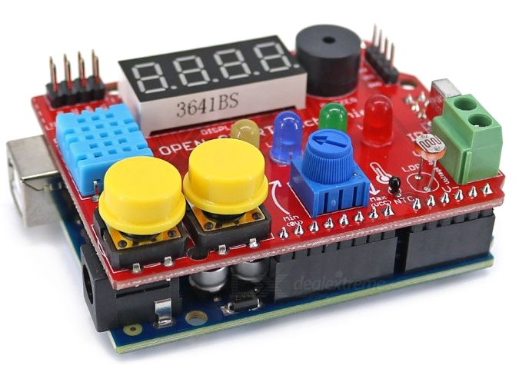

In order to be able to program the Arduino UNO we need software to write the program. This software is available online.

Download the Arduino IDE for your respective operating system from: <https://www.arduino.cc/en/Main/Software>

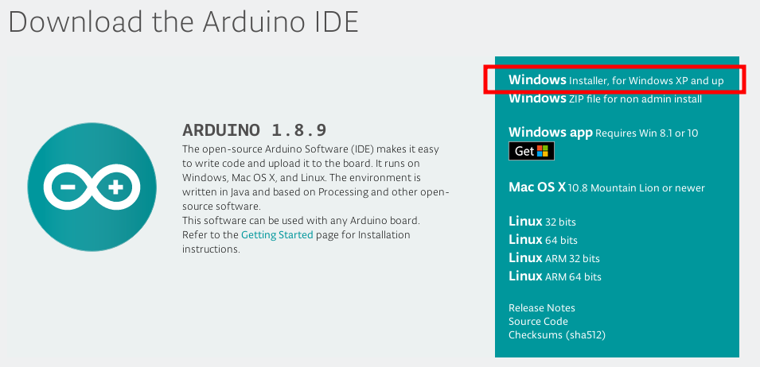

Plug your Arduino into your PC

Start the application and go to Tools -> Board, then select “Arduino/Genuine UNO” (If you are using a different model Arduino, then find the correct model in the list.

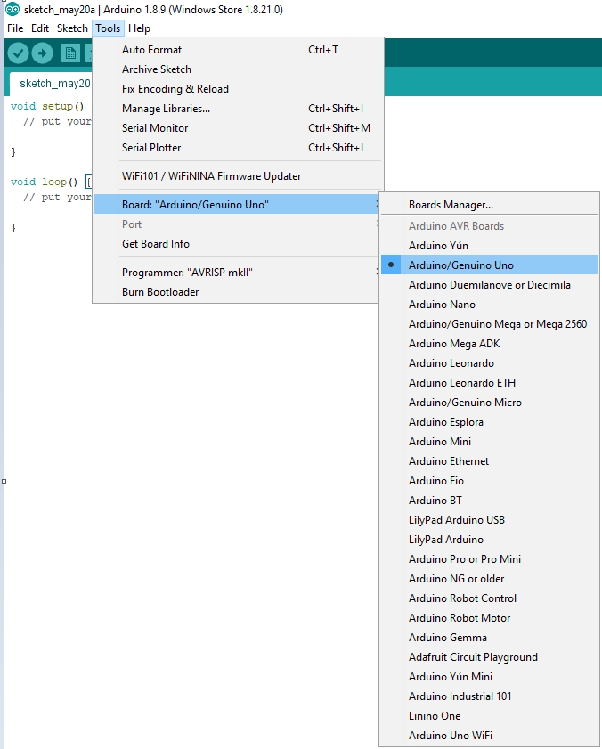

Afterwards, again from the Tools -> Port and select the port that the Arduino has been plugged into (IDE should be showing only one option, unless you are using two Arduinos. If no options are showing up, check if your Arduino is plugged in. If it plugged in but not recognized try unplugging it, wait 20 seconds and plug it back in.

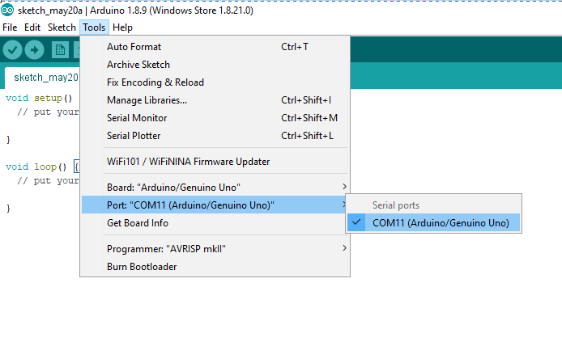

# Week 1

## Getting started

Read the followings Arduino beginner’s tutorial.

<https://www.makerspaces.com/wp-content/uploads/2017/02/Arduino-For-Beginners.pdf>

<https://www.introtoarduino.com/downloads/IntroArduinoBook.pdf>

## Simply serial

Now it is time for you to find out what your lifesaver when programming in Arduino is. This tool is called a “Serial Monitor”. It can be used for various things, but you will(probably) use it a lot for debugging. Debugging is the process of finding mistakes in your code. Due to the Arduino IDE not being as advanced as other IDE’s (e.g. Visual Studio), a simple way to find out what your code is doing is by writing something to the Serial Monitor, whenever you reach a certain point in your code. That way if the Serial Monitor does not show what your expect, it didn’t reach the line your expected. You still have to figure out yourself what the actual mistake is.

Now let’s try to use the Serial Monitor:

First open a new Arduino Sketch:

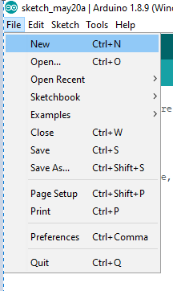

Now copy the following code into your program

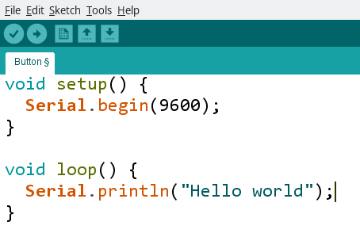

First with Serial.begin() you set the rate at which you will transmit data. The number 9600 is this data rate, called “baud rate”. The actual value is not of importance right now: 9600 is a good and stable choice. Then with Serial.println() you tell the Arduino to print whatever is in between the parenthesis (don’t forget the quotations (“ “)). Now it is time to upload your code. First click the “tick button”

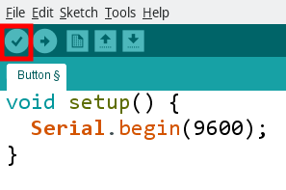

This button checks your program for any typing errors (called syntax errors),such as a missing semicolon (“;”) or forgetting to close a quotation mark: “

If your code is free of mistakes you’ll see the following result in the bottom of your sketch:

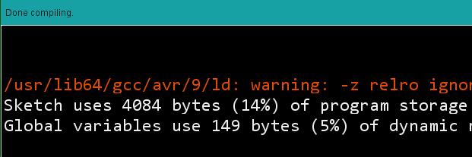

If you made a mistake you’ll see error messages.

Next click the arrow button next to it, which will upload your code to your Arduino (if you have plugged it in).

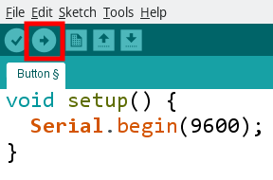

Finally, when the program has uploaded, click the magnifying glass in the top right corner of the IDE. It will open the serial monitor:

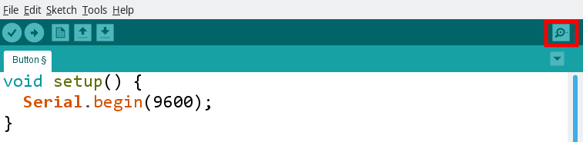

The output should be something like this:

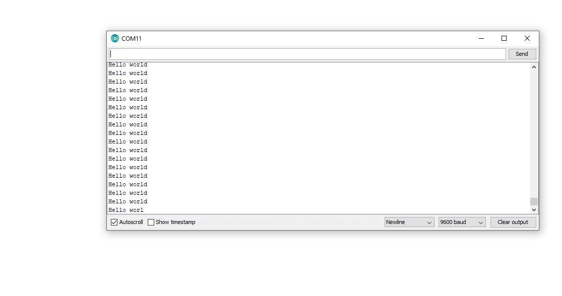

This means that the program is working, and your Arduino is writing “Hello world” on the serial monitor constantly as intended. Good job!